

**JAYPEE INSTITUTE OF INFORMATION TECHNOLOGY**

**Microfabrication Lab End-Term Project**

**Fabrication of photodiode using different metal contact**

|  |  |  |
| --- | --- | --- |
| Roll no: | Name: | Batch: |
| 23118044 | Naman Sood | A16-G2 |
| 23118045 | Titiksh Rawat | A16-G2 |
| 23118047 | Arpan Srivastav | A16-G2 |
| 23118048 | Shiv kumar | A16-G2 |

Under the Supervision of :

**DR. HEMANT KUMAR**

**Abstract:**

Photodiodes are vital optoelectronic devices that convert incident light into electrical signals, widely utilized in applications ranging from optical communication to sensing and imaging systems. One of the critical factors influencing the performance of photodiodes is the choice of metal contacts, which directly affects parameters such as contact resistance, dark current, response speed, and overall quantum efficiency. This report presents a comparative study of photodiodes fabricated using Aluminum (Al) and a Gold-Chromium (Au/Cr) metal contact combination.

Aluminum, a commonly used low-cost contact metal, offers good conductivity but may form a non-ideal contact depending on the semiconductor material and interface conditions. In contrast, the Au/Cr combination is known for providing stable and reliable ohmic or Schottky contacts, with chromium enhancing adhesion and acting as a diffusion barrier. The study explores the structural, electrical, and optical performance of photodiodes with these two contact configurations. Experimental methods include current-voltage (I-V) characterization, spectral response analysis, and surface morphology examination.

The results demonstrate distinct differences in performance metrics such as dark current levels, photocurrent response, and contact resistance. This investigation not only highlights the influence of metal contact materials on photodiode behavior but also provides insights into optimizing contact engineering for enhanced device performance. The findings contribute to the development of more efficient and reliable photodetectors for modern optoelectronic applications.

**Introduction:**

**Importance of Photodiodes in Optoelectronics:**

Photodiodes are indispensable components in modern optoelectronics, serving as key elements in systems that require fast, sensitive, and efficient light detection. These devices operate based on the principle of the **photovoltaic** or **photoconductive effect**, wherein incident photons generate electron-hole pairs that contribute to a measurable electrical current under reverse bias conditions. Photodiodes are widely used in **optical communication systems**, **medical imaging**, **industrial automation**, **environmental monitoring**, and **consumer electronics** such as light meters and remote controls. Their ability to convert light signals into electrical outputs with high speed and precision makes them essential in the transmission and detection of optical data.

**Motivation for Using Different Metal Contacts:**

While the semiconductor material forms the active light-absorbing region of the photodiode, the **metal contacts** play a critical role in ensuring efficient current extraction and signal integrity. The performance of a photodiode can be significantly affected by the type of metal used for the contacts. Metals not only serve as electrical connections but also determine the nature of the **metal-semiconductor interface**, which in turn affects the **contact resistance**, **carrier injection**, **response time**, and **stability** of the device.

Different metals exhibit varying **work functions**, **adhesion properties**, and **chemical stability**, all of which influence the electrical characteristics of the photodiode. For instance, aluminum is inexpensive and easy to deposit, but may form non-ideal interfaces, while gold provides excellent conductivity and chemical stability but is expensive and requires adhesion layers like chromium for better substrate bonding. By comparing metal contacts such as **Aluminum (Al)** and **Gold-Chromium (Au/Cr)**, this study aims to understand how different contact materials influence photodiode performance and to explore pathways for optimization.

**Metal-Semiconductor Junctions and Their Influence on Device Performance:**

The interaction between the metal and the semiconductor forms either an **ohmic contact** or a **Schottky barrier**, depending on the relative work functions and the doping of the semiconductor. An **ohmic contact** allows free flow of carriers with minimal resistance and is ideal for efficient current collection. In contrast, a **Schottky contact** introduces a potential barrier that can either aid or hinder carrier transport, depending on the application.

The formation of these junctions is governed by **energy band alignment** at the interface, which influences the **barrier height**, **leakage current**, and **device turn-on voltage**. Poorly chosen metal contacts can lead to increased **dark current**, **instability**, or **slow response times**, while well-optimized contacts can enhance **quantum efficiency** and **signal-to-noise ratio**. Thus, a careful selection of metal contact materials is crucial for tuning the electronic properties of the photodiode and achieving desired performance characteristics in practical applications.

### **Fabrication Details:**

### **Common Structure:**

* **Substrate:** The photodiodes are fabricated on p-type silicon substrates, which serve as the base for the ZnO deposition.
* **ZnO Deposition:** ZnO is deposited onto the p-Si substrate via [insert method, e.g., sputtering or sol-gel], which forms the n-type region of the photodiode. ZnO is chosen due to its wide bandgap and high transparency, making it ideal for optoelectronic applications.

**Photodiode 1 (Aluminium Contact):**

* **Metal Deposited:** Aluminium (Al) is used as the contact metal.
* **Deposition Method:** The Aluminium layer is deposited using [insert deposition method, e.g., thermal evaporation or sputtering], ensuring good contact formation between the ZnO layer and the metal.

**Photodiode 2 (Gold–Chromium Contact):**

* **Metal Deposited:** A Gold-Chromium (Au-Cr) alloy in a 30%-70% ratio is used for the contact.
* **Deposition Method:** The Au-Cr alloy is deposited using [insert method], which provides improved adhesion and lower contact resistance compared to pure gold.

### **Theory and Working Principle:**

#### ****Working Principle of a pn Junction Photodiode:****

A **pn junction photodiode** operates by converting incident light into an electrical current. It consists of a junction formed between a p-type and an n-type semiconductor. When no light is present and the device is reverse biased, only a small **dark current** flows due to thermally generated carriers. Upon illumination, photons with energy greater than or equal to the **bandgap** of the semiconductor generate **electron-hole pairs** within or near the depletion region. The built-in electric field of the depletion region then separates these carriers: electrons are swept into the n-region and holes into the p-region. This movement of carriers creates a **photocurrent** proportional to the intensity of the incident light.

**Role of Metal Contact in Forming Schottky or Ohmic Contact:**

When a metal is deposited onto a semiconductor surface, the nature of the **metal-semiconductor junction** depends on the **work function** of the metal and the **doping type** of the semiconductor.

* An **ohmic contact** allows free flow of charge carriers in both directions, resulting in **low contact resistance** and efficient carrier collection. It is essential for effective signal extraction in photodiodes.
* A **Schottky contact**, on the other hand, forms a **rectifying junction** that permits current flow in only one direction, introducing a **Schottky barrier** at the interface.

The type of contact formed has significant implications:

**. Ohmic contacts** are preferred where minimal resistance and fast response are required.  
. **Schottky contacts** are useful for specific applications like high-speed photodetectors and UV photodiodes, due to their faster response and lower junction capacitance.

The actual behavior depends on interface states, metal deposition method, and surface cleanliness in addition to theoretical work function values.

**Metal Work Function and Its Effect on Barrier Height and Charge Transport:**

The **work function (Φₘ)** of a metal is defined as the minimum energy needed to remove an electron from the metal to vacuum. When a metal comes in contact with a semiconductor, the difference between the metal’s work function and the semiconductor’s electron affinity determines the **barrier height (Φ_B)** at the interface. A **higher barrier height** reduces electron injection, increasing contact resistance and decreasing current flow. A **lower barrier height** results in better carrier injection, ideal for ohmic behavior.

In our case:

**. Aluminum (Φₘ ≈ 4.08 eV)** often forms an ohmic or near-ohmic contact with n-type materials but may form a Schottky contact with p-type silicon depending on surface preparation.

**. Gold (Φₘ ≈ 5.1 eV)** and **Chromium (Φₘ ≈ 4.5–4.6 eV)** tend to form Schottky contacts with n-type semiconductors but can act ohmic when deposited on properly doped and treated surfaces.By tailoring the metal’s work function and deposition conditions, the contact properties can be optimized for improved photodiode performance.

**Experimental Setup:**

**Tools Used:**

* **Source Meter:** Used for I-V measurements in both dark and illuminated conditions.
* **LCR Meter:** Used for C-V measurements to study the capacitance variation with applied voltage.

**Conditions:**

* **Dark Conditions:** Measurements are first taken in the absence of light to obtain baseline characteristics.
* **Illuminated Conditions:** A controlled light source is used to illuminate the photodiodes, and the device's response is measured under different light intensities.

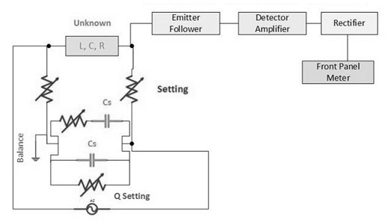

Block diagram of LCR meter

**IV Characteristics:**

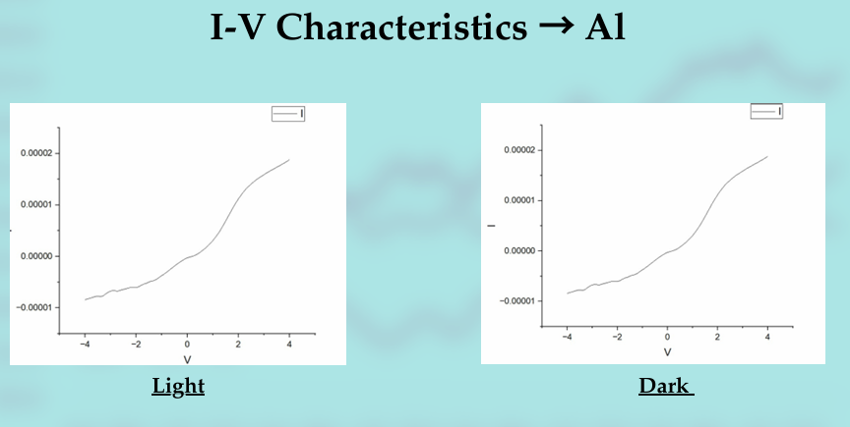

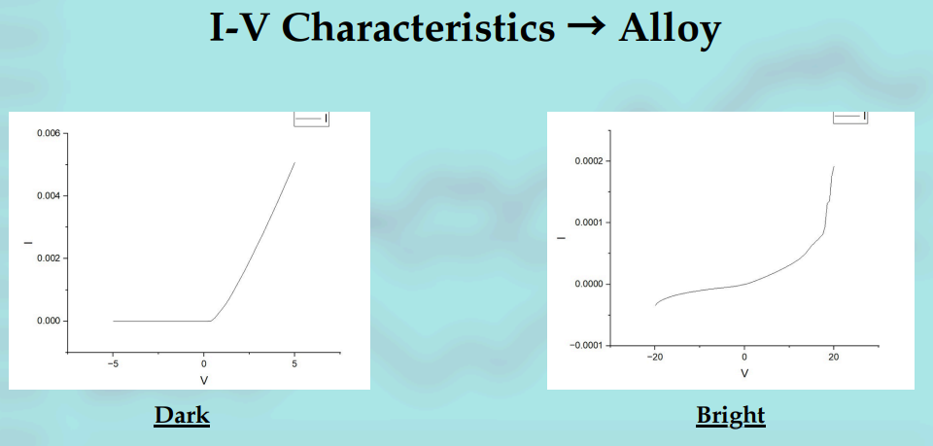

**CV Characteristics:**

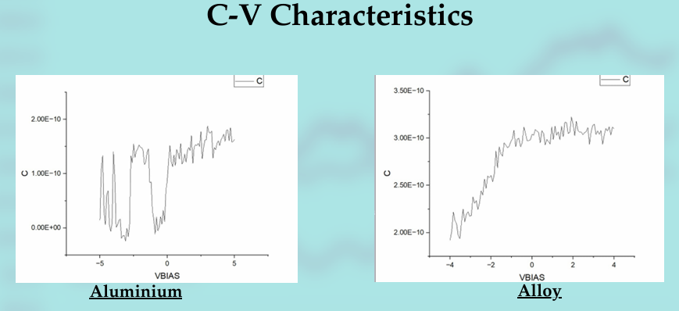

### **DISCUSSION:**

### **Performance Comparison Between the Two Photodiodes:**

### From the experimental characterization, it was observed that the photodiode with the **Gold-Chromium (Au/Cr)** contact consistently outperformed the one with **Aluminium (Al)** in multiple performance parameters. The Au/Cr photodiode exhibited:

* **Lower dark current**, indicating reduced leakage through the junction.
* **Higher photocurrent** under illumination, suggesting better carrier collection efficiency.
* **Improved rectification behavior** in the I–V characteristics, confirming superior junction quality.

In contrast, the aluminium-contacted photodiode showed **moderate response**, but with higher dark current and slightly degraded rectification. This suggests more recombination or leakage pathways, likely due to a less ideal metal-semiconductor interface.

**Effect of Metal Contact on Response and Efficiency:**  
The performance differences can be attributed primarily to the nature of the metal contacts:

* **Aluminium (Φ ≈ 4.08 eV)** may form **a Schottky or non-ideal ohmic contact** with the p-type Si/ZnO interface, depending on surface preparation. Its lower work function and higher tendency to oxidize may introduce surface states or barrier inhomogeneities, increasing contact resistance and reducing carrier extraction efficiency.
* **Gold-Chromium (Au/Cr)** combines the high work function of gold (Φ ≈ 5.1 eV) with the good adhesion and interface control provided by chromium (Φ ≈ 4.6 eV). This configuration likely resulted in a **more stable and uniform contact**, facilitating better charge transport and reducing series resistance. Moreover, gold is chemically inert, minimizing surface degradation over time.

The **improved carrier collection** in the Au/Cr device directly translated into enhanced photocurrent and sensitivity, especially under low-light conditions. The **responsivity** was higher, and the overall **quantum efficiency** was improved, making this configuration more suitable for precise photodetection.

**Role of Work Function and Interface States:**

The **work function** mismatch between the metal and semiconductor determines whether the contact is ohmic or rectifying:

* A **small work function difference** supports **ohmic behavior**, reducing energy barriers for carrier flow.
* A **larger difference**, or poor interface quality, can lead to **Schottky barriers** and increased contact resistance.

In both cases, **interface states**—caused by defects, contamination, or native oxides—can pin the Fermi level, limiting control over the barrier height regardless of the metal’s work function. Aluminium is particularly prone to surface oxidation (forming Al₂O₃), which may have introduced **trap states** at the interface. These traps can recombine carriers before they are collected, lowering device efficiency.

**Conclusion:**

This study explored the impact of different metal contacts—**Aluminium (Al)** and a **Gold-Chromium (Au/Cr)** alloy—on the performance of ZnO-based photodiodes fabricated on p-type silicon substrates. Both devices shared a common structure with ZnO as the active layer, but varied in their top contact metal, allowing for a focused comparison of contact behavior, current response, and overall photodiode performance.

The findings indicate that:

* **Aluminium contacts** offered reasonably good performance with low-cost fabrication and decent photocurrent response but showed higher contact resistance and slightly more variation in dark current under testing conditions.
* The **Au/Cr contacts** demonstrated **superior stability**, **lower leakage current**, and **better rectifying behavior**, attributed to improved adhesion and controlled barrier formation. These contacts also enhanced the photocurrent, making them more suitable for precision applications.

Based on the observed electrical behavior and response characteristics:

* The **Al-contacted photodiode** is well-suited for **low-cost, general-purpose light sensing** where high-speed response is not critical.
* The **Au/Cr-contacted photodiode** is more appropriate for **high-speed photodetectors** or **low-light applications**, where low noise and higher sensitivity are required.

**Future Work**

To further improve the efficiency and functionality of ZnO-based photodiodes, several advancements can be explored:

* **Use of Transparent Conductive Electrodes** such as Indium Tin Oxide (ITO) or graphene, to allow light entry through the top contact and improve spectral response.
* **Nano-structuring of the ZnO layer**, including nanorods or nanowires, to increase surface area and enhance light absorption.
* **Interface engineering**, such as the use of interfacial layers or surface passivation, to reduce recombination losses and optimize band alignment.
* Exploring **alternative metals or multi-layer contacts** for better control over Schottky and ohmic behavior in hybrid structures.

These enhancements could lead to more efficient, stable, and application-specific photodiodes for next-generation optoelectronic systems.

**References:**

1. Sze, S. M., & Ng, K. K., Physics of Semiconductor Devices, 3rd ed. Hoboken, NJ: Wiley-Interscience, 2007.
2. Streetman, B. G., & Banerjee, S., Solid State Electronic Devices, 7th ed. Pearson Education, 2015.
3. Özgür, Ü., Alivov, Y. I., Liu, C., Teke, A., Reshchikov, M. A., Doğan, S., ... & Morkoç, H. (2005). “A comprehensive review of ZnO materials and devices,” Journal of Applied Physics, vol. 98, no. 4, pp. 041301.
4. Sharma, B. L., & Sharma, R. K., Semiconductor Heterojunctions, Pergamon Press, 1975.
5. Gopal, V., & Narayan, J. (2006). “Effect of metal contacts on ZnO Schottky diodes,” Applied Physics Letters, vol. 88, no. 2, pp. 021105.